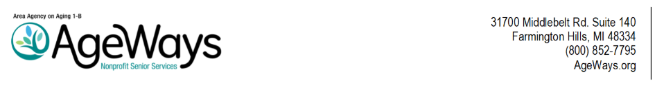

AGEWAYS NONPROFIT SENIOR SERVICES
Board of Directors Meeting
Friday, July 31, 2026, 9:45 – 11:45 a.m.

AGENDA

9:30 |  | Call to Order and Roll Call
9:35 |  | Call to the Public
9:40 |  | Agenda Approval  Action is requested to approve the agenda for the July 31, 2026, Board of Directors meeting.

AGENDA ITEMS

9:42 | I. | Minutes of the June 26, 2026, Board of Directors Meeting . . . . . . . . . . . . . . .  Action is requested to approve the June 26, 2026, Board of Directors Meeting Minutes. | Doc 1
 | II. | Application Review Committee (ARC) Recommendations . . . . . . . . . . . . . . .  Presenters:  Sandra Hann, First Vice Chairperson and ARC Chairperson  Kristin Wilson, Assistant Director, Community Health and Aging Services  Action is requested to approve the recommendations of the Application Review Committee. | Doc 2a-b
10:45 |  | Adjournment

Next Board of Directors Meeting
Friday, August 28, 2026

