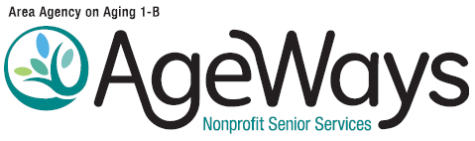

Advisory Council Meeting
Wednesday, October 15, 2025, 9:30 – 11:30 a.m.

AGENDA

Microsoft Teams Meeting
Join on your computer or mobile app.
Click here to join the meeting.
Meeting ID: 294 325 774 938, Passcode: e2Jz6TP6

or

Call in (audio only)
+1 989-341-4489, Phone conference ID: 146 721 473#

9:30 |  | Call to Order and Roll Call
9:35 |  | Introductions
9:38 |  | Call to the Public
9:42 |  | Agenda Approval  Action requested to approve the agenda for the October 15, 2025, Advisory Council Meeting.
AGENDA ITEMS

9:44 | I. | Minutes of the August 20, 2025, Advisory Council meeting . . . . . . . . . . .  Action requested to approve the minutes of August 20, 2025, Advisory Council meeting. | Doc 1
9:47 | II. | Michigan Senior Advocates Council (MSAC) and Senior Advisory Council (SAC) Report  Presenter(s): MSAC Member(s) and SAC Member(s)  - Informational
9:55 | III. | Executive Summary: FY2025 Year in Review . . . . . . . . . . . . . . . . . . . . . .  Presenter: Michael Karson, CEO  - Informational | Doc 3
10:15 | IV. | 2025 Needs Assessment – Review of Results . . . . . . . . . . . . . . . . . . . . . . . . . .  Presenter: Katheryn Scharf, Planning and Grants Specialist  - Informational | Doc 4
10:40 | V. | Update - Federal and State Budgets  Presenter: Katheryn Scharf, Planning and Grants Specialist  - Informational
10:55 | VI. | Medicare Open Enrollment Support . . . . . . . . . . . . . . . . . . . . . . . . . . . . .  Kathleen Yanik, Director of Communications and Outreach  - Informational | Doc 6a-b
11:10 | VII. | Member Information Exchange  - Please share any ideas for the recurring agenda item - “Your Questions Answered”  - The following topic was received after the August meeting: the impact of current federal administration policy on undocumented caregivers.  - Please remember you can always email suggestions for topics to vfitzgerald@ageways.org.
11:20 | VIII. | Adjournment

Next Advisory Council Meeting

Wednesday, November 19, 2025, 9:30 – 11:30 a.m.

