

The Senior Resource Expo is an annual event to help

Saturday,
September 28
10:00 a.m. to
3:00 p.m.
provide seniors and caregivers learn about resources throughout the area. The 2024 event is expected to
feature over 80 experts, companies, organizations, and NGOs from Livingston County and surrounding areas.
This year we are also pleased to be able to add
nationally-renowned presenter, Breeda Miller, who will be performing “Mrs. Kelly’s Journey Home.” Tickets for this performance typically run upwards of
New Location:
2/42 Community Church
7526 Grand River Ave,
Brighton, MI 48114
$30 but it will be FREE for all attendees, sponsors, and vendors.
There will be food and drink available for purchase so be sure to bring some cash.

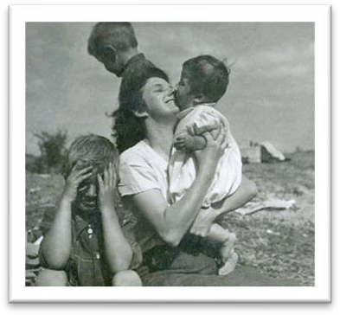

“Mrs. Kelly’s Journey Home” … A Performance by Breeda Miller
Breeda Kelly Miller brings to life a funny and often profound look at
her mother's journey from her native Ireland through the end of her life, charting the type of experiences felt by generations of immigrants and adults caring for their aged parents. This is a theatrical memoir, with
Breeda performing each role, introducing us to her parents, their
families, and friends. Mrs. Kelly's Journey Home will keep audiences riveted from the opening line to the closing blessing. It is a moving, joyous exploration of love, roots, and family.
For more information and/or tickets to the Senior Resource Expo, please go to: http://www.livingstoncoa.org/

