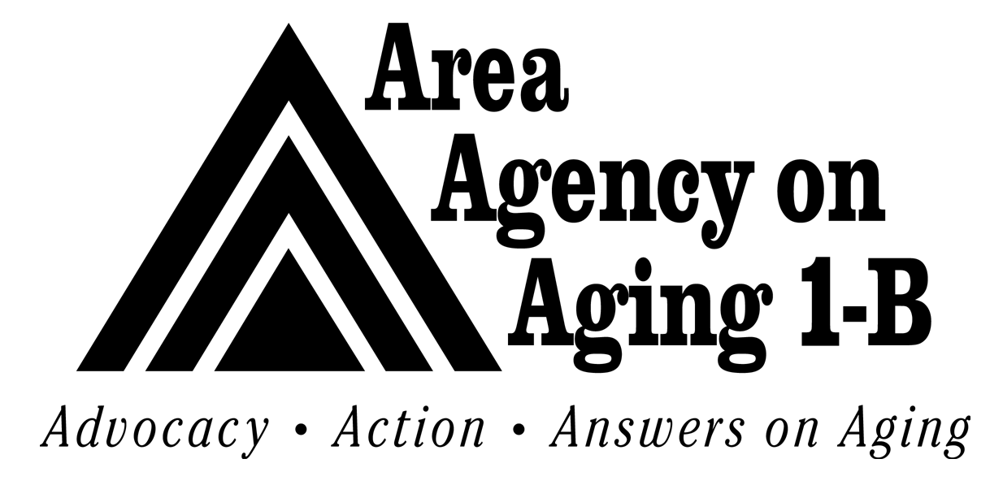
AREA AGENCY ON AGING 1-B SERVICE PROVIDER
REQUEST OF WAIVER OF SERVICE PROVISION
STANDARD FORM

Name of Agency Date

Requesting Waiver of Standard:

Reason for Request:

Documentation Submitted:

Proposed Date Waiver to take effect (if approved):

AAA 1-B Comments:

_______________________________ _____________________
Signature/Title Date

Reviewed By:
Program Manager/Fiscal Manager |  | Date
Community & Business Advancement Director |  | Date

APPROVED DENIED

AAA 1-B CEO |  | Date

